Exercise 3 – Student Marks Processing
Workflow
create_marks_file
↓
calculate_average
↓
generate_result
Input
/tmp/marks.txt
Content:
Math,80
Science,75
English,90
Python,95

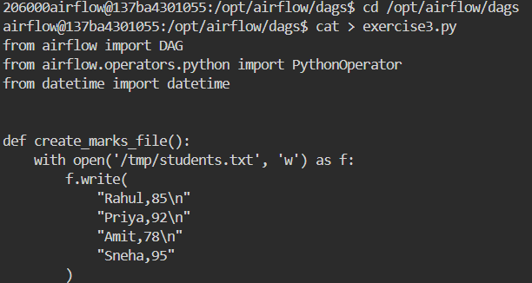

Python Code:
from airflow import DAG
from airflow.operators.python import PythonOperator
from datetime import datetime

def create_marks_file():
with open('/tmp/students.txt', 'w') as f:
f.write(
"Rahul,85\n"
"Priya,92\n"
"Amit,78\n"
"Sneha,95"
)

def calculate_average():
total_marks = 0
student_count = 0

with open('/tmp/students.txt', 'r') as f:
for line in f:
name, marks = line.strip().split(',')
total_marks += int(marks)
student_count += 1

average = total_marks / student_count

with open('/tmp/average.txt', 'w') as f:
f.write(str(average))

def generate_result():
with open('/tmp/average.txt', 'r') as f:
average = f.read()

with open('/tmp/students.txt', 'r') as f:
count = len(f.readlines())

with open('/tmp/result.txt', 'w') as f:
f.write(
"Student Result Report\n"
f"Students = {count}\n"
f"Average Marks = {average}"
)

with DAG(
dag_id='exercise3_student_result',
start_date=datetime(2025, 1, 1),
schedule=None,
catchup=False
) as dag:

task1 = PythonOperator(
task_id='create_marks_file',
python_callable=create_marks_file
)

task2 = PythonOperator(
task_id='calculate_average',
python_callable=calculate_average
)

task3 = PythonOperator(
task_id='generate_result',
python_callable=generate_result
)
task1 >> task2 >> task3

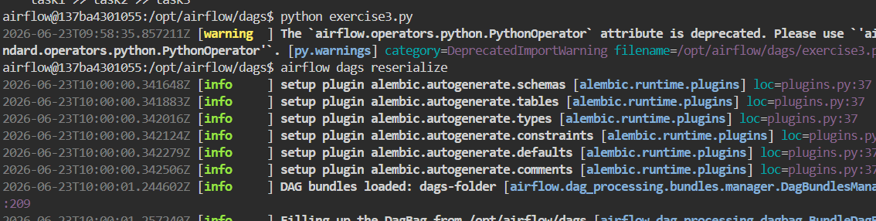

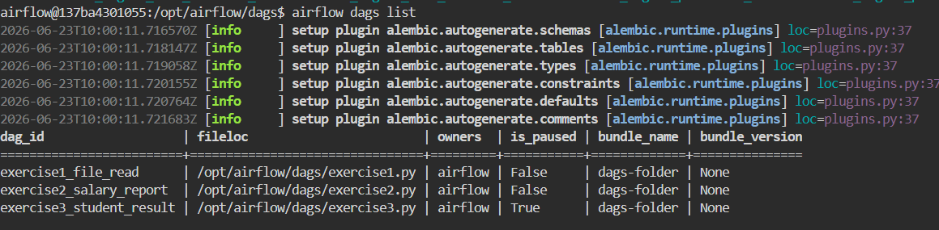

Task 2
Calculate average marks.
Expected:
Average = 85

Task 3
Generate:
/tmp/result.txt

Content:
Average Marks = 85
Result = PASS

Output:
